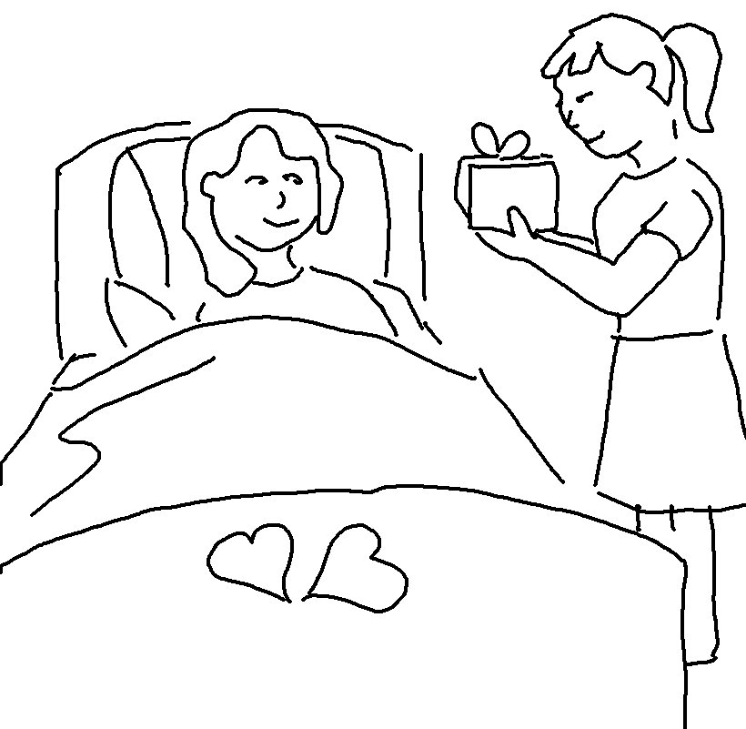
Let your good deeds shine out for all to see, so that everyone will praise your heavenly Father.
Matthew 5:16 _{NLT}

